**A PROJECT REPORT ON**

**“Development of noodles making machine”**

**For the mini project of third year of Engineering in Mechanical Engineering**

**By**

**TADAVI ASHISH SHABBIR**

**BACHHAV DIPALI BHAURAO**

**MAHAJAN MAHESH RAJMAL**

Under the Guidance of

**Prof. P.V.WASHIMKAR**

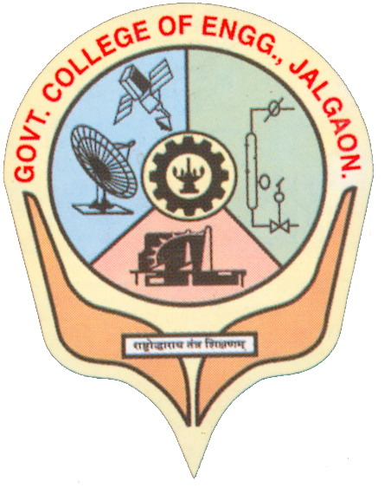

**DEPARTMENT OFMECHANICAL ENGINEERING**

**GOVERNMENT COLLEGE OF ENGINEERING, JALGAON 425002**

**APRIL2018**

**GOVERNMENT COLLEGE OF ENGINEERING, JALGAON**

**Department of Mechanical Engineering**

**CERTIFICATE**



This is to certify that the project entitled, **“Development of noodles making machine”**, which is being submitted herewith **TADAVI ASHISH SHABBIR,BACHHAV DIPALI BHAURAO,MAHAJAN MAHESH RAJMAL** for the award of T.E., is the result of the work completed by under my supervision and guidance within the four walls of the institute and the same has not been submitted elsewhere for the award of any degree.

Place: Jalgaon

Date:

DR.P.V.WASHIMKAR DR.M.J.SABLE

**Guide Head of Mechanical Department**

Prof. Dr. R. P. Borkar

**Principal Examiner**

**DECLARATION**

We hereby declare that the project entitled, **“DEVELOPMENT OF NOODLES MAKING MACHINE”** was carried out and written by me under the guidance of DR.P.V.WASHIMKAR Assistant Professor, Department of Mechanical Engineering at Government College of Engineering,Jalgaon. This work has not been previously formed the basis for the award of any degree or diploma or certificate nor has been submitted elsewhere for the award of any degree or diploma.

**TADAVI ASHISH SHABBIR**

**BACHHAV DIPALI BHAURAO**

**MAHAJAN MAHESH RAJMAL**

**Date:**

**Place: Jalgaon**

**ACKNOWLEDGEMENT**

Success is never achieved single-handed. Apart from our humble efforts, this project is outcome of the help, co-operation and guidance from various corners. We would like to add a few heartfelt words for the people who were part of this project in numerous ways and the people who gave unending support right from the stage of project ideas.

It gives me great pleasure in presenting the report of our project. We take this opportunity to express our deep sense of gratitude to my guideDR.P.V.WASHIMKAR **,** Assistant professor of Mechanical Engineering Department, Government college of Engineering, Jalgaon for his valuable guidance and inspiration. In spite of his busy schedules he devoted himself and took keen and personal interest in giving me constant encouragement and timely suggestion.

We would like to express our deep sense of gratitude toDR.M.J.SABLE Associate Professor and Head of Mechanical Engineering Department.Also here we would like to thank our honorable Principal **Prof.Dr. R.P. Borkar** for giving me opportunity to present this project report.

Finally we take the opportunity to convey the sincere thanks to all my friends and staff members those who contributed to let me bring out our project report as it appears.

With deep reverences!

**ABSTRACT**

The objective of this project is to design noodles making machine. There are many noodles making machines available in market but a small gap between the electrical machines and manual pressed machine is there in the market; so to reduce that gap between heavy electrical machine and small pressed machine this project has been design.There are many small home based businesses run by women’s in Indiabut production is in very small quantity so to give them effective desired machine this machine has been design.

In this project we have used mechanical advantage by the means of lever and different mechanisms such as ratchet and pinion. To combine the theoretical knowledge and practical knowledge of simple mechanical elements and to use those simple element and to make a price worthy machine. Globallythe market of noodleindustry is nearly 128.7billion USD So there is huge demand for machines.

***contents***

|  |  |  |
| --- | --- | --- |
| Sr. No. | name | Page no |
| 1 | Certificate |  |
| 2 | Declaration |  |
| 3 | Acknowledgement |  |
| 5 | Abstract |  |
| 6 | Contents |  |
| 7 | List of figures |  |
| 8 | List of tables |  |
| 9 | Nomenclature |  |
| 10 | introduction |  |
| 11 | Statement of project |  |
| 12 | Overview of project |  |
| 13 | Objective of project |  |
| 14 | Need of project |  |
| 15 | Market and literature survey |  |
| 16 |  |  |
|  |  |  |

**LIST OF TABLES**

|  |  |  |
| --- | --- | --- |
| **Table No.** | **Title** | **Page No.** |
| 6.1 | Cost estimation | 29 |

**NOMENCLATURE**

1. **Kurdai+ shevayas = Noodles**
2. **Sut=ultimate tensile strength**
3. **syt=yield strength**
4. **D=Diameter**
5. **F=Force**
6. **P=Pressure**

**Introduction**

Our day starts with noodles and ends with noodles .in everyday we are used to eat Maggie and many types of product like that. The industry of noodles is also growing rapidly ;also there are many small scale businesses in rural India like making “Shevayas and kurdai(forms of noodles)” which are so make by machines which is not possible to buy such type of machinery ordinary women’s for making it commercialized; hence they use small types of manual pressing machine which is not so easy to operate and handle and to make some quantity of noodles, such that it can be sold in market with marginal profit is not possible.

Therefore our project fills that gap of costly equipment and very cheap equipment. Here we used very simple mechanical elements and mechanisms to get desired output such that gears and rack etc.

Hence hereby we are glad to design such small scale product that will make many Indian women’s economically strong and independent of anyone.

**Statement of the Project**

The future of noodles market can be expected from the following lines from ‘Grand review research’,

**“The global pasta and noodles market is anticipated to reach USD 81.7 billion by 2025, according to a new report by Grand View Research, Inc. Launch of wide variety of new products, and instant food for working professionals are the key factors that are driving the market GROWTH”**.

Again our aim is to make a machine which will be up to3500rupees and up to 14 th of April . In which we will take the help of many noodle making women’s in India to get the prize in which such machine they want. It also includes many vendors to provide small mechanical elements and a workshop where we can give shape to our ideas.

**PROJECT OVERVIEW**

As third year mechanical engineer we are designing a project that will combine our whole study, into aproject by using small elements such as gears and shaft, lever, racketc.; such that we will get a useful design product which can sell in the market. Hence we design such a product in the benefit of Indian house women’s by making their interest as our prime goal by introducing noodle making machines. This took a lot of efforts to design gears and get one standard which will suit our need.

Using such small elements we have made an assemblywhich will function better than existing design of machines available in the market. We have used cost efficient elements by keeping cost as our prime gal to reduce it certainly. Here we have used many personals to make this design possible.

**Objective of the project**

The objective of this project is such that it will desired output as noodles with18000mm3/sec volume flow rate at an effort of 20-50N applied at lever. Other objective of this project is such that the project oe design should be of maximum 3500 rupees.

**Need for project**

As it is clear from the previous articles that the need to give a machines to common peoples and to make them economically stable and to design a machine which will give desired output in less effort. Again to reduce that gap between costly and cheaper machines this project has been designed .

1. **Market and literature survey**
2. History
3. Today’s market machines and there advantages and dis-advantages.
4. Gap

**a) History**[**1**](noodles%20history.pdf)

Chinese noodles originated in the Han dynasty, which has more than 4,000 extent, noodles also reflect the cultural traditions and customs of China, which essentially means “human nature” and “worldly common sense”. There are thousands of varieties of noodles in China, according to the classification of the shape of noodles, seasoning gravy, cooking craft, and so on.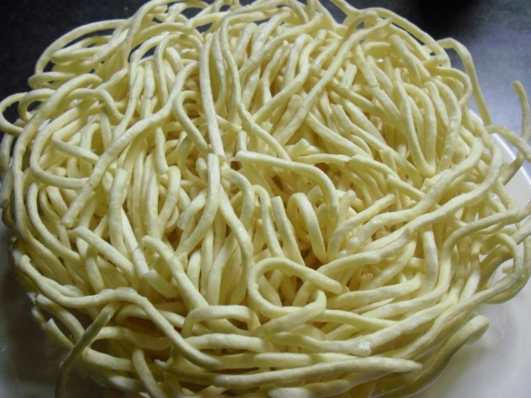

Many noodles have local characteristics. Noodles are accepted by people from all over the world. The industrial revolution and the development of the food industry realized the transition from a traditional handicraft industry to mass production using machinery. In addition, the invention of instant noodles and their mass production also greatly changed the noodle industry. In essence, noodles are a kind of cereal food, which is the main body of the traditional Chinese diet. It is the main source of energy for Chinese people and the most economical energy food. Adhering to the principle of “making cereal food the main food”, is to maintain our Chinese good diet tradition, which can avoid the disadvantages of a high energy, high fat, and low carbohydrate diet, and promote health. The importance of the status of noodles in the dietary structure of residents in our country and the health impact should not be ignored.

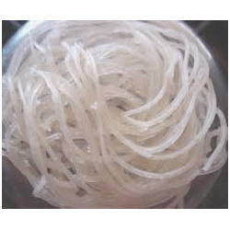 In India we are used to eat shevaya and kurdai it has long history in which it is eaten withvarieties oil and food and like that.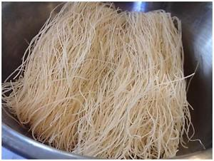they are manufactured by varietiessuch as by rolling at homes on a pad of wood or by using cylinder as storing elements and pressing it by punch by hands.

**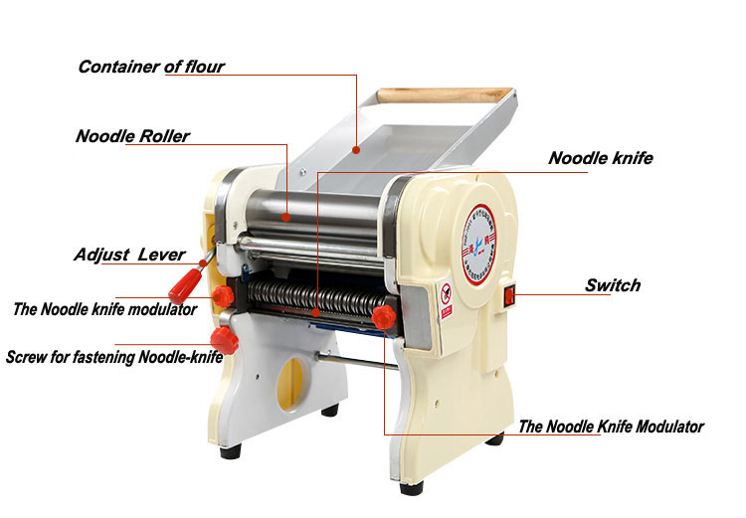b) Today’s market machines and there advantages and dis-advantages.**

Today there are many machines available in the markets which are really good but costly or cheaper but unsatisfactory in work for example take following examples

1) ***Electricalmachines::***

Cost: 10000 rupees

Size:500\*500\*700mm

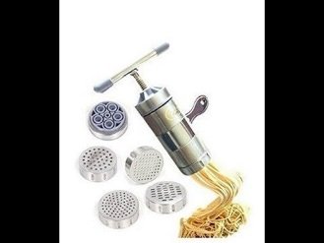Motor size 2.00HP

***2) Pressing simple machine:***

Cost:500rupees

Size-21 x 18 x 5 cm

Power - 200 W

3)Gap

From following differentiation it can be seen that it is not possible for small work to used electrical machines. Hence there is gap of cost and production which our design full fills.

***2.Elements used in design and assembly and desembly***

**elements:**

1. lever and strip
2. gears
3. rack and pinion
4. shaft
5. bush
6. cylinder and punch
7. basic elements for base

***Assembly and whole design***

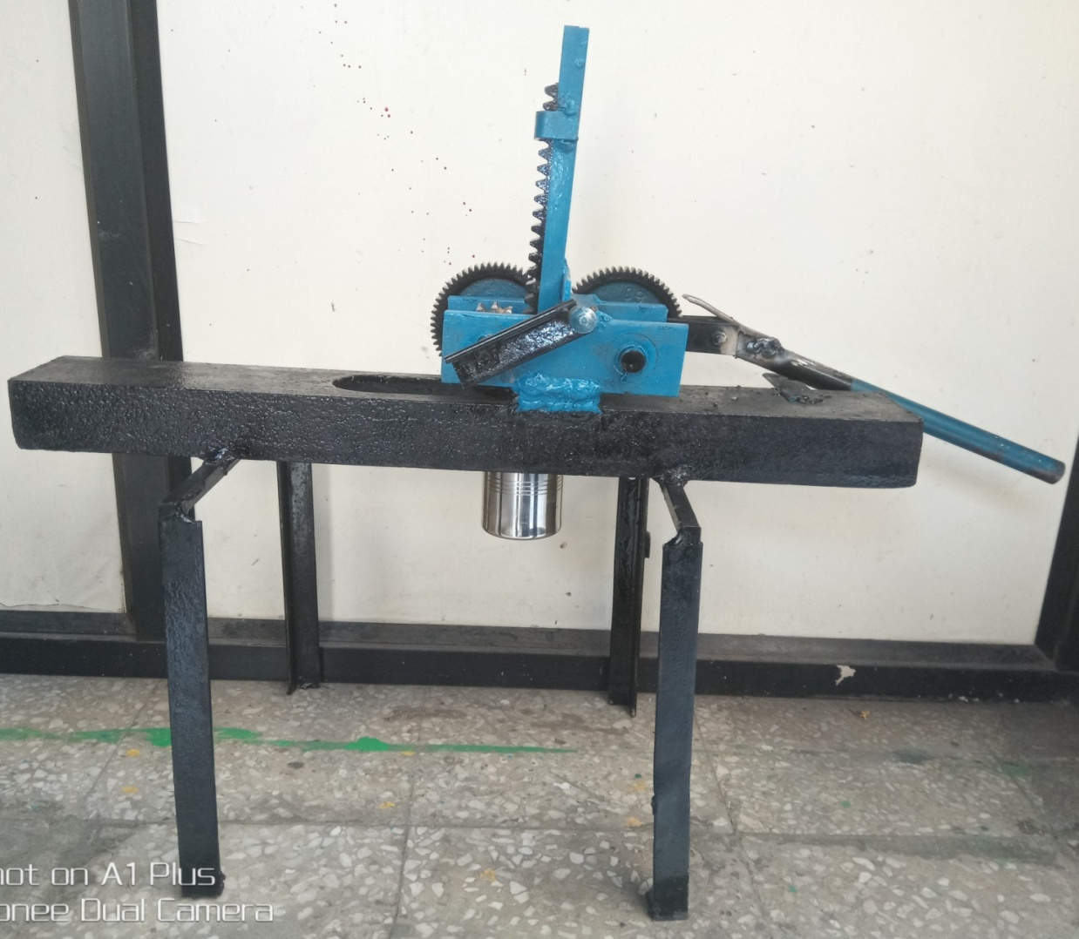

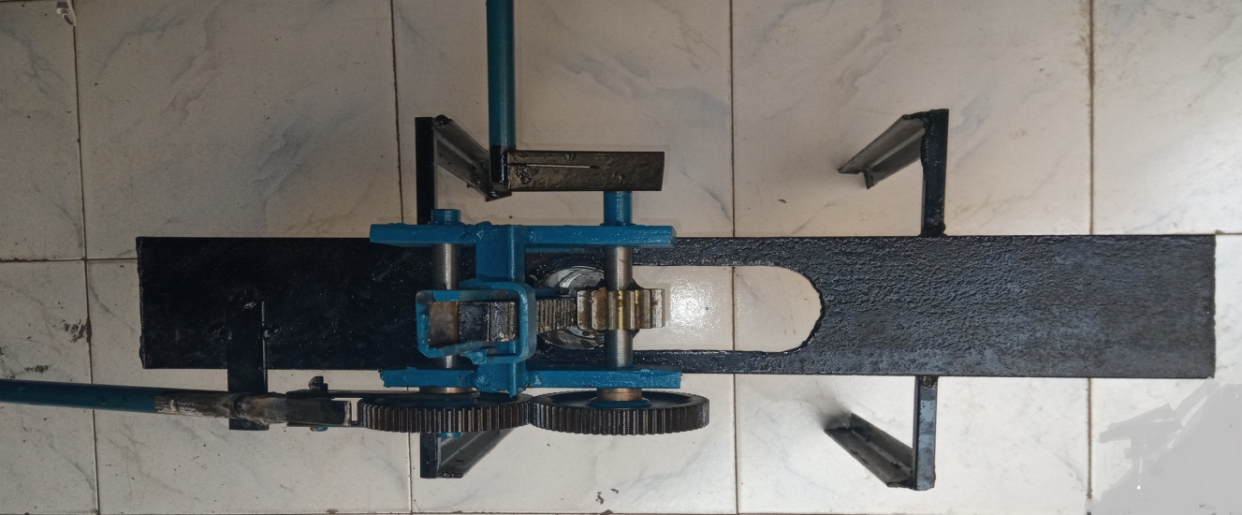

***2.Different mechanism used for this design***

***a)similar mechanism to ratchet***

A **ratchet** is a mechanical device that allows continuous linear or rotary motion in only one direction while preventing motion in the opposite direction. Ratchets are widely used in machinery and tools. Though something of a misnomer, "ratchet" is also often used to refer to ratcheting [socket wrenches](https://en.wikipedia.org/wiki/Socket_wrench), a common tool with a ratcheting handle.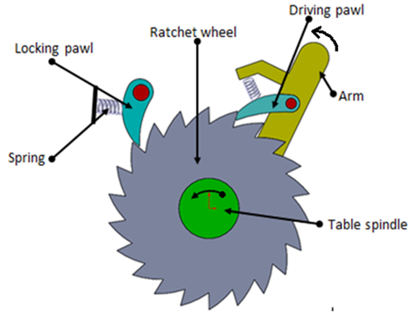 Ratchet mechanisms are used in a wide variety of applications, including these:

* [Capstans](https://en.wikipedia.org/wiki/Capstan_%28nautical%29)
* [Clocks](https://en.wikipedia.org/wiki/Clock)
* [Freewheel](https://en.wikipedia.org/wiki/Freewheel) (overrunning clutch)
* [Jacks](https://en.wikipedia.org/wiki/Jack_%28device%29)
* [Anti-rollback devices](https://en.wikipedia.org/wiki/Lift_hill#Anti-rollback_device) used in [roller coasters](https://en.wikipedia.org/wiki/Roller_coaster)
* [Slacklines](https://en.wikipedia.org/wiki/Slacklining)
* [Tie down straps](https://en.wikipedia.org/wiki/Tie_down_straps)
* [Turnstiles](https://en.wikipedia.org/wiki/Turnstile)
* [*Handcuffs*](https://en.wikipedia.org/wiki/Handcuffs)

***working-***

A ratchet consists of a round [gear](https://en.wikipedia.org/wiki/Gear) (see Figure 1) or linear [rack](https://en.wikipedia.org/wiki/Rack_and_pinion) with teeth, and a pivoting, spring-loaded finger called a *pawl* (or *click*, in clocks and watches[[1]](https://en.wikipedia.org/wiki/Ratchet_%28device%29#cite_note-1)[[2]](https://en.wikipedia.org/wiki/Ratchet_%28device%29#cite_note-2)) that engages the teeth. The teeth are uniform but [asymmetrical](https://en.wikipedia.org/wiki/Asymmetry), with each tooth having a moderate slope on one edge and a much steeper slope on the other edge.

When the teeth are moving in the unrestricted (i.e., forward) direction (see Figure 2), the pawl easily slides up and over the gently sloped edges of the teeth, with a spring forcing it (often with an audible 'click') into the depression between the teeth as it passes the tip of each tooth. When the teeth move in the opposite (backward) direction, however, the pawl will catch against the steeply sloped edge of the first tooth it encounters, thereby locking it against the tooth and preventing any further motion in that direction.

**Backlash**

Because the ratchet can only stop backward motion at discrete points (i.e., at tooth boundaries), a ratchet does allow a limited amount of backward motion. This backward motion—which is limited to a maximum distance equal to the spacing between the teeth—is called [backlash](https://en.wikipedia.org/wiki/Backlash_%28engineering%29). In cases where backlash must be minimized, a smooth, toothless ratchet with a high friction surface such as [rubber](https://en.wikipedia.org/wiki/Rubber) is sometimes used. The pawl bears against the surface at an angle so that any backward motion will cause the pawl to jam against the surface and thus prevent any further backward motion. Since the backward travel distance is primarily a function of the compressibility of the high friction surface, this mechanism can result in significantly reduced backlash.

***advantages***

The paper presents a ratchet and pawl ring (RaPR) mechanism that has advantages for mechanical safety mechanisms, particularly when the design envelop is too small to allow for traditional mechanical components. The mechanism constraints are outlined and the RaPR mechanism and its modeling are defined.

Ratchets can serve as a useful mechanism in many different applications.

**Socket Wrench**

**Turnstile**

**Zip Tie**

**Ratchet Straps**

***2.Gear and its design***

**Gears** are deﬁned as toothed wheels or multilobed cams, which transmit power and motion from one shaft to another by means of successive engagement of teeth.

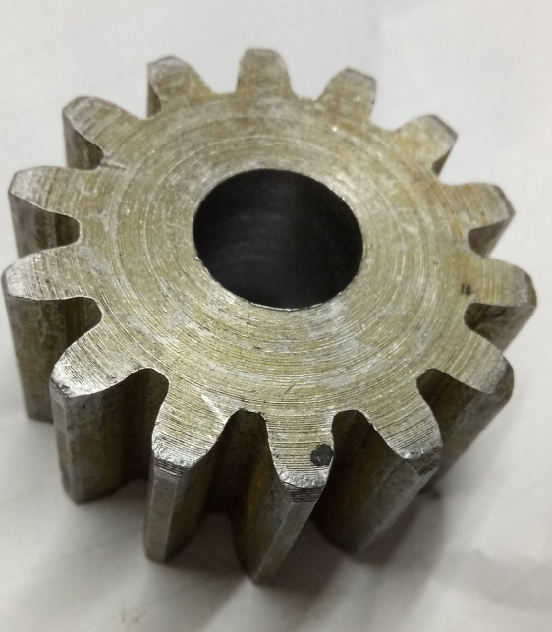

Gear drives offer the following advantages compared with chain or belt drives: (i) It is a positive drive and the velocity ratio remains constant. (ii) The centre distance between the shafts is relatively small, which results in compact construction. (iii) It can transmit very large power, which is beyond the range of belt or chain drives. (iv) It can transmit motion at very low velocity, which is not possible with the belt drives. (v) The efﬁciency of gear drives is very high, even up to 99 per cent in case of spur gears. (vi) A provision can be made in the gearbox for gear shifting, thus changing the velocity ratio over a wide range. Gear drives are, however, costly and their maintenance cost is also higher. The manufacturing processes for gears are complicated and highly specialized. Gear drives require careful attention for lubrication and cleanliness. They also require precise alignment of the shafts.

# 

A **gear** or **cogwheel** is a [rotating](https://en.wikipedia.org/wiki/Rotating) [machine](https://en.wikipedia.org/wiki/Machine_%28mechanical%29) part having cut *teeth*, or cogs, which mesh with another toothed part to transmit [torque](https://en.wikipedia.org/wiki/Torque). Geared devices can change the speed, torque, and direction of a [power source](https://en.wikipedia.org/wiki/Power_%28physics%29). Gears almost always produce a change in torque, creating a [mechanical advantage](https://en.wikipedia.org/wiki/Mechanical_advantage), through their [gear ratio](https://en.wikipedia.org/wiki/Gear_ratio), and thus may be considered a [simple machine](https://en.wikipedia.org/wiki/Simple_machine). The teeth on the two meshing gears all have the same shape.[[1]](https://en.wikipedia.org/wiki/Gear#cite_note-1) Two or more meshing gears, working in a sequence, are called a [gear train](https://en.wikipedia.org/wiki/Gear_train) or a [*transmission*](https://en.wikipedia.org/wiki/Transmission_%28mechanics%29). A gear can mesh with a linear toothed part, called a rack, producing [translation](https://en.wikipedia.org/wiki/Translation_%28physics%29) instead of rotation.

The gears in a transmission are analogous to the wheels in a crossed, belt [pulley](https://en.wikipedia.org/wiki/Pulley) system. An advantage of gears is that the teeth of a gear prevent slippage.

When two gears mesh, if one gear is bigger than the other, a mechanical advantage is produced, with the [rotational speeds](https://en.wikipedia.org/wiki/Rotational_speed), and the torques, of the two gears differing in proportion to their diameters.

In transmissions with multiple gear ratios—such as bicycles, motorcycles, and cars—the term "gear" as in "first gear" refers to a gear ratio rather than an actual physical gear. The term describes similar devices, even when the gear ratio is [continuous](https://en.wiktionary.org/wiki/continuous) rather than [discrete](https://en.wiktionary.org/wiki/discrete), or when the device does not actually contain gears, as in a [continuously variable transmission](https://en.wikipedia.org/wiki/Continuously_variable_transmission)

# How Gears Work

# They do several important jobs, but most important, they provide a [gear reduction](https://science.howstuffworks.com/transport/engines-equipment/gear-ratio.htm) in motorized equipment. This is key because, often, a small motor spinning very fast can provide enough [power](https://science.howstuffworks.com/transport/engines-equipment/fpte5.htm) for a device, but not enough [torque](https://science.howstuffworks.com/transport/engines-equipment/fpte3.htm). For instance, an electric screwdriver has a very large gear reduction because it needs lots of torque to turn screws, bu­t the motor only produces a small amount of torque at a high speed. With a gear reduction, the output speed can be reduced while the torque is increased.

**Gear Materials**

The material used for the manufacture of gears depends upon the strength and service conditions like wear, noise etc. The gears may be manufactured from metallic or non-metallic materials. The metallic gears with cut teeth are commercially obtainable in cast iron, steel and bronze. The nonmetallic materials like wood, rawhide, compressed paper and synthetic resins like nylon are used for gears, especially for reducing noise. The cast iron is widely used for the manufacture of gears due to its good wearing properties, excellent machinability and ease of producing complicated shapes by casting method. The cast iron gears with cut teeth may be employed, where smooth action is not important. The steel is used for high strength gears and steel may be plain carbon steel or alloy steel. The steel gears are usually heat treated in order to combine properly the toughness and tooth hardness.

The following are the advantages and disadvantages of the gear drive as compared to other drives, i.e. belt, rope and chain drives :

***Advantages***

1. It transmits exact velocity ratio.

2. It may be used to transmit large power.

3. It may be used for small centre distances of shafts.

4. It has high efficiency.

5. It has reliable service.

6. It has compact layout.

***Disadvantages***

1. Since the manufacture of gears require special tools and equipment, therefore it is costlier than other drives.

2. The error in cutting teeth may cause vibrations and noise during operation.

3. It requires suitable lubricant and reliable method of applying it, for the proper operation of gear drives

**The list below shows the main application fields**

* Factory automation
* Packaging machine
* Industrial robots
* Food processing machine
* Car production machine
* Machine tool industry
* Material handling
* Printing machine
* Automatic cutting / welding machine
* Machine for medical/cosmetic field
* Construction machine
* Wood / Glass processing machine
* Agricultural machinery

**spur gear-***Spur gears* or *straight-cut gears* are the simplest type of gear. They consist of a cylinder or disk with teeth projecting radially. Though the teeth are not straight-sided (but usually of special form to achieve a constant drive ratio, mainly [involute](https://en.wikipedia.org/wiki/Involute_gear) but less commonly [cycloidal](https://en.wikipedia.org/wiki/Cycloid_gear)), the edge of each tooth is straight and aligned parallel to the axis of rotation. These gears mesh together correctly only if fitted to parallel shafts.[[12]](https://en.wikipedia.org/wiki/Gear#cite_note-12) No axial thrust is created by the tooth loads. Spur gears are excellent at moderate speeds but tend to be noisy at high speed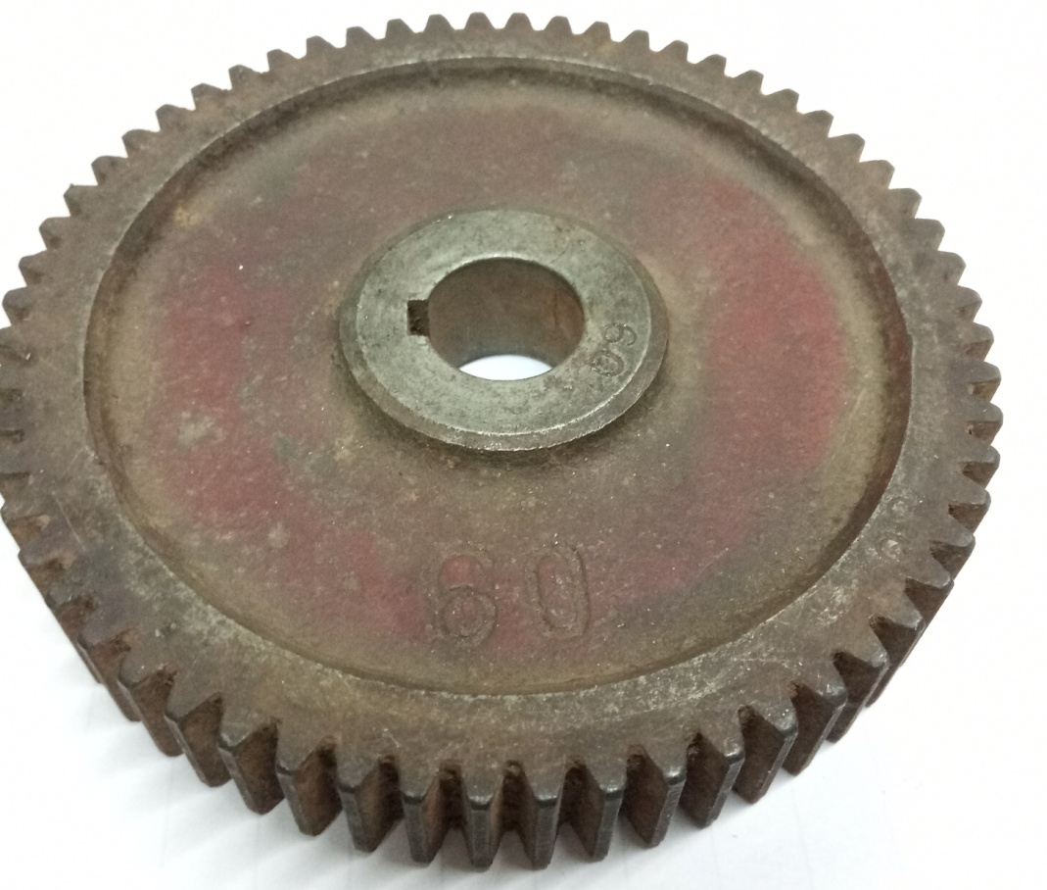

***CALCULATION FOR DIAMENSIONS OF GEAR 1 and2***

1. **Gear 1**

Given:

Gear chosen is 200 full depth involute gear having following properties

Gear chosen is spur gear as we don’t have to work on too much heavy loads and power transmitted equals less that 0.5 HP and quite motion is not our prime requirement

outer diameter=98

Inner diameter=92

Hence

M=module=(98-94)/2.25=1.6mm

Module to preferred series is =1.6mm

D(pitch)=z\*m=\*60=94 mm

Z=60 teeth

Length of lever=295

Diameter of gear =94

Total length is=295+47=343mm

Torque to be transmitted is equal to

T=f\*r

=50\*347

=17350 N.mm

pt=tangential force=2\*T/dp

Pt=2\*17150/96

=357.24 N

***Dimensions of gear 2***

As both gear are of same size and characteristics hence same torque will be transmitted from gear 1 to gear 2

And hence to shaft no 2

Same as that of gear 1

D(pitch)=96mm

Torque=17350 N.mm

M=1.6 mm

Z=60 teeth

***Design of rack and pinion***

**Rack& pinion-**A rack is a toothed bar or rod that can be thought of as a sector gear with an infinitely large radius of curvature. Torque can be converted to linear force by meshing a rack with a pinion: the pinion turns; the rack moves in a straight line. Such a mechanism is used in automobiles to convert the rotation of the [steering](https://en.wikipedia.org/wiki/Steering) wheel into the left-to-right motion of the tie rod(s). Racks also feature in the theory of gear geometry, where, for instance, the tooth shape of an interchangeable set of gears may be specified for the rack, (infinite radius), and the tooth shapes for gears of particular actual radii are then derived from that. The rack and pinion gear type is employed in a [rack railway](https://en.wikipedia.org/wiki/Rack_railway).

**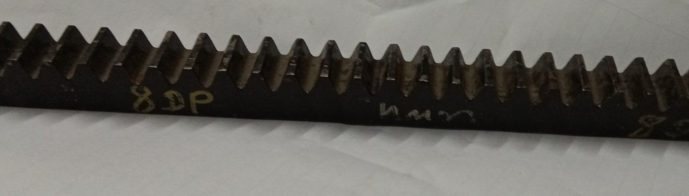**

**RACK**

***Design of gear 3 (pinion of rack)***

Outer diameter is =51 mm

Inner diameter is =37mm

M=(51-37)/2.25=6.22mm

Next preferred value is 7mm

dp(pitch) =z\*m=45mm

Z=14

System of gear used is 200degree full depth involute teeth

As gear 2 and pinion are on same shaft same torque will be transmitted from it

T=17350 N.mm

Pt3=2\*T/dp

=2\*17350/45

=771.11 N

As this pt3 same force will be transmitted form pinion to rack tangentially that will be responsible for movement and pressing force.

***Design of rack***

The rack and pinion both were taken in conjugation and have same module and diametric pitch.

Material of rack 30C8

Width=20mm

Thickness=20mm

Length=300mm

Diametric pitch=8mm

As from market we took the closest gear which will give desired output. We find this rack and pinion as our final full filling rack and pinion. From this we got the next desired dimensions. Such as bush dimensions and other values.

***3.Shaft and its design***

The term ‘transmission shaft’ usually refers to a rotating machine element, circular in crosssection, which supports transmission elements like gears, pulleys and sprockets and transmits power. A transmission shaft supporting a gear in a speed reducer is shown in Fig. 9.1. The shaft is always stepped with maximum diameter in the middle portion and minimum diameter at the two ends, where bearings are mounted. The steps on the shaft provide shoulders for positioning transmission elements like gears, pulleys and bearings. The rounded-off portion between two cross-sections of different diameters is called ﬁ llet. The ﬁ llet radius is provided to reduce the effect of stress-concentration due to abrupt change in the cross-section.

Shafts are given speciﬁc names in typical applications, although all applications involve transmission of power, motion and torque.

A shaft is a rotating machine element which is used to transmit power from one place to another. The power is delivered to the shaft by some tangential force and the resultant torque (or twisting moment) set up within the shaft permits the power to be transferred to various machines linked up to the shaft. In order to transfer the power from one shaft to another, the various members such as pulleys, gears etc., are mounted on it. These members along with the forces exerted upon them causes the shaft to bending. In other words, we may say that a shaft is used for the transmission of torque and bending moment. The various members are mounted on the shaft by means of keys or splines.

**Material Used for Shafts**

The material used for shafts should have the following properties : 1. It should have high strength. 2. It should have good machinability. 3. It should have low notch sensitivity factor. 4. It should have good heat treatment properties. 5. It should have high wear resistant properties. The material used for ordinary shafts is carbon steel of grades 40 C 8, 45 C 8, 50 C 4 and 50 C 12.

transmission shafts are made of medium carbon steels with a carbon content from 0.15 to 0.40 per cent such as 30C8 or 40C8. These steels are commonly called machinery steels. Where greater strength is required, high carbon steels such as 45C8 or 50C8 or alloy steels are employed. Alloy steels include nickel, nickel–chromium and molybdenum steels. Common grades of alloy steels used for making transmission shafts are 16Mn5Cr4, 40Cr4Mo2, 16Ni3Cr2, 35Ni5Cr2, 40Ni6Cr4Mo2 and 40Ni10Cr3Mo6. Alloy steels are costly compared with plain carbon steels

***Calculations for shaft***

We take mild steel as material for shaft having properties as follow

Sut=440 N/mm2

Syt=N/mm2

BHN=126

Let

FS =6

From distortion energy theory as it gives most suitable failure criteria of ductile material

Shear stress ()=.577\*syt/fos

=.577\*370/6

=35.5816 N/mm2

To calculate the diameter of shaft

D=diameter of shaft

=16\*t/(π\*d3)

D=

D=13.4897mm

But the minimum size of bush available in the market is 16\*28\*40

Hence the inner diameter of shaft is equal to 16 mm

And our design is safe as diameter is greater than 14mm

Hence

D=16mm

**4.Bush**

A **bush** is a mechanical fixing between two, possibly moving, parts, or a strengthened fixing point where one mechanical assembly is attached to another. In a car or other vehicle's [suspension](https://simple.wikipedia.org/wiki/Suspension_%28vehicle%29), bushes are used to connect the various moving arms and [pivot](https://simple.wikipedia.org/w/index.php?title=Pivot&action=edit&redlink=1) points to the [chassis](https://simple.wikipedia.org/wiki/Chassis) and other parts of the suspension. In machines bush provide mechanical strength to the rotor.

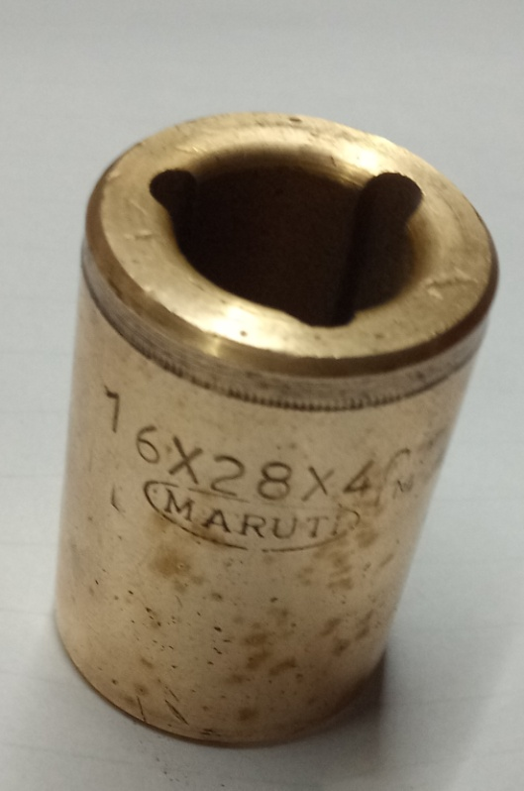

The bush material would be of a softer material than the shaft/spindle that runs inside it, often bronze, even oil impregnated bronze.

A cylindrical or conical part of a machine, mechanism, or instrument, which has an axial opening into which another part fits. Depending on their purpose, a distinction is made among bearing linings, fastener bushings, adapters, and so on.

A bearing lining is the part of a bushed sliding bearing in which the journal of a shaft or axle rotates. Such a bushing is fitted tightly into the housing portion and is sometimes also held with screws. It is made of antifriction materials (cast iron, bronze, graphite, or plastics), cast iron or steel with a thin layer of antifriction material on the friction surface, or a porous, self-lubricating metal ceramic. The use of bushings in sliding bearings reduces the consumption of costly and usually scarce antifriction materials (tin bronzes and babbitt metal) and simplifies repair by reducing it to the replacement of a worn bushing with a new one.

Fastener bushings secure the inner rings of antifriction bearings and other parts on the cylindrical portions of shafts and axles. They are made in a split form, with a conical outer surface, and are tightened by means of a nut.

An adapter is used to mount a tool with a conical shank in a lathe spindle that has a hole larger than the tool shank.

The reasons for using the bush are that the bush will wear out before the bearing or the shaft/spindle, therefore reducing the time and costs of replacing the bearing or shaft. It would usually be sensible to carry spare bronze bearings already made to size to allow for a fast replacement.

The bush itself is a bearing that normally we call a bush bearing.mainly we use bush bearing

1.where one piece anti friction bearing can not be fitted like engine connecting rod big end bearing,large mill bearings bearings are

2.bush bearings are cheaper than anti friction bearings.

3.where bearing is to be accommodated in two pieces. Although new anti friction bearings are coming in two pieces..

4.used in airfoil bearings in aircraft jet engines and industrial turbo blowers being the most efficient over anti friction bearings.for being maintenance free and highly energy efficient.

However many bush bearings are being replaced with anti friction bearings for ease of maintenance and better life.

***Size of bush***

The least size of bush available in the market is 16\*28\*40mm

As bearing of this size is too costly and also not available in the market easily of this size hence we choose this bonze bush which is not too costly and friction is very small

Also our shaft size can’t be increase from 16 mm hence this bush is selected.

But the hole size in the plate is equal to 24 mm

Hence we do turning operation such that to make transition fit

And it will fit hole of plate on which whole assembly is erected.

***5.cylinder and its design***

## A cylinder, has traditionally been a three-dimensional solid, one of the most basic of [curvilinear](https://en.wikipedia.org/wiki/Curvilinear) geometric shapes. It is the idealized version of a solid physical [tin can](https://en.wikipedia.org/wiki/Tin_can) having lids on top and bottom.This traditional view is still used in elementary treatments of geometry, but the advanced mathematical viewpoint has shifted to the [infinite](https://en.wikipedia.org/wiki/Infinite_set) curvilinear [surface](https://en.wikipedia.org/wiki/Surface_%28mathematics%29) and this is how a cylinder is now defined in various modern branches of geometry and to pology.

## 20180407_201359.jpg

## The shift in the basic meaning (solid versus surface) has created some ambiguity with terminology. It is generally hoped that context makes the meaning clear. In this article both points of view are presented and distinguished by referring to *solid cylinders* and *cylindrical surfaces*, but keep in mind that in the literature the unadorned term cylinder could refer to either of these or to an even more specialized object, the *right circular cylinder*. Material that is most commonly used is cast aluminium alloy but in some case cast iron. Cast iron has the economic advantage, but aluminium is lightweight and has good thermal conduction properties. Also, if piston is lightweight, it provides very less out of balance reciprocating force which in turn reduces the weight of counterbalance. It affects the noise, vibration, harshness and the durability of the engine.

***Design of cylinder***

Outer diameter=60mm

Inner diameter =51 mm

Thickness=(60-56)/2

= 2 mm

The force applied by punch equals =771.11N

P=pressure

P=f\*4/(π\*d2)

=771.11\*4/(π\*56\*56)

=.312642 N/mm2

Considering cylinder ad a pressure vessel having inner dia 56mm

And inner pressure .312642 N/mm2

T=thickness

T=p\*d/(ft\*2)

Ft=tensile stress

FS=4

Material for cylinder is stainless steel grade 316 (UNSS 31600)

Having following properties

Syt=480mpa

Ft=480/4

=120N/mm2

T=.312642\*56/(2\*120)

=.0730mm

Such thickness is not possible to achieve hence we go according to market availability

Hence we choose the market available cylinder which has greater thickness than which we are required here and is equal to 2mm

**steps to be followed for making noodles from noodles making machine**

***Bill of material***

|  |  |  |  |  |  |
| --- | --- | --- | --- | --- | --- |
| Sr.no | Name of element | Material | Quantity | Size | Price |
| 1 | 1inch angle | Steel | 1 | 5feet | 80 |
| 2 | 4 inch channel | Cast iron | 1 | 2 feet | 200 |
| 3 | Square bar | Steel | 1 | 2 feet | 20 |
| 4 | Strip | Steel | 1 | 1.5 feet | 60 |
| 5 | Gear | 30c8 | 2 | 4 D.P | 250 |
| 6 | Rack and pinion | Mild steel | Each 1 | 8 D.P | 720 |
| 7 | Cylinder and punch | Stainless steel | Each 1 | 56 mm | 250 |
| 8 | Bush | Brass | 2 | 16\*28\*40 | 400 |
| 9 | Shaft | 30c8 | 1 | 2.5 feet | 350 |
|  | total |  |  |  | 2330 Rs |

***Conclusion***

Hereby we are glad to design the project which will be benifitial for common womens in india .This project uses the simple mechanical elements such as gears ,shaft to transmit the torque and lever for using the mechanical advantages. As gears has high efficiency such as 98 % . The cost of design is nearly 2700 Rs and the designed product is easy to use and operate for uneducated womens in India .

***Reference***

1. Noodles traditionally and toody by Na Zang, Guansheng Ma.
2. Basics of engineering design by V.B.Bhandari
3. Wikipedia
4. Internet
5. Elements of machine design by Khurmi.